**A* Algorithm**

The A* (A-star) algorithm is a popular pathfinding and graph traversal algorithm used in computer science, particularly in artificial intelligence for navigation and pathfinding in games. It finds the shortest path from a start node to a target node using a $heuristic$ to prioritize which nodes to explore.

**Key Concepts[1]**

1. **Graph Representation**:
   * Nodes represent locations.
   * Edges represent the cost to move between locations.
2. **Cost Function**:
   * **a(n)**: The cost from the start node to node n.
   * **h(n)**: A heuristic estimate of the cost from node n to the target node. It should be admissible (never overestimate the actual cost) and ideally consistent (the estimated cost should be less than or equal to the step cost).
3. **Evaluation Function**:
   * **g(n) = a(n) + h(n)**: This is used to prioritize which nodes to explore next. The algorithm always expands the node with the lowest g(n) value.

**Algorithm Steps**

1. **Initialization**:
   * Create two lists: **open** (nodes to be evaluated) and **closed** (nodes already evaluated).
   * Add the starting node to the open list.
2. **Loop**:
   * While the open list is not empty:
     1. Find the node n with the lowest a(n) in the open list. Remove it from the open list.
     2. If n is the target node, reconstruct the path and exit.
     3. Add n to the closed list.
     4. For each neighbor of n:
        + If it is in the closed list, ignore it.
        + Calculate g and a values.
        + If it is not in the open list, add it.
        + If it is already in the open list and the new path to it is shorter, update its g and f values.
3. **Path Reconstruction**:
   * If the target node was reached, backtrack from the target node to the start node using pointers to reconstruct the path.

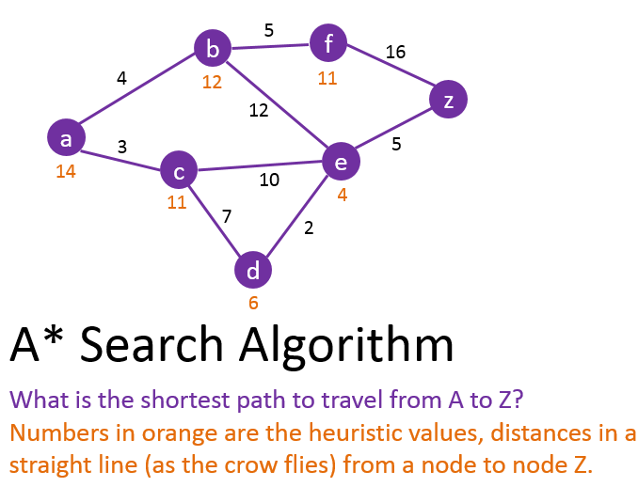

g(n)=a(n)+h(n)

where a(n) is actual cost, h(n) is heuristic cost and g(n) is the cost of specific path.

**Applications**

* Game development for NPC pathfinding.
* Robotics for navigation.
* Geographic information systems (GIS).
* Network routing protocols.

**Advantages**

* A* is complete and optimal (if the heuristic is admissible).
* Efficient and works well for many types of pathfinding scenarios.

**Disadvantages**

* Performance can degrade in environments with many obstacles.
* Requires good heuristics to function optimally.

Top of For

Bottom of Form**Summary:**

The A* algorithm effectively navigates the grid by using cost functions to evaluate and prioritize paths, ensuring that it finds the most efficient route from the start to the goal while avoiding obstacles.

1. A **heuristic** is a rule of thumb or a problem-solving approach that simplifies the process of finding solutions, particularly in complex problems where an exhaustive search is impractical. In the context of algorithms, particularly pathfinding and search algorithms like A*, heuristics are used to estimate the cost or distance from a current node to the goal node.

   **Key Characteristics of Heuristics:**

   **Estimation**: Heuristics provide a way to estimate the value or cost of a solution without computing it exhaustively. This estimation helps prioritize which paths to explore first.

   **Guidance**: They guide the search process, helping algorithms to focus on promising paths rather than exploring every possible route. This can significantly reduce computation time.